
SANO SEEDING COMB
Sano Sadbový hrebeň
Sano Sadbový hřeben
Sano Grzebień do siewu
Sano Hullámos vetőgerinc
Sano Cresta de siembra
Sano Saatkamm
EU RCD ( Registered Community Design / Registered Community Design): 15112651-0001. Applicant ( Applicant ID): 2578281 – SANOVATO, Category: Professional ecological seed comb
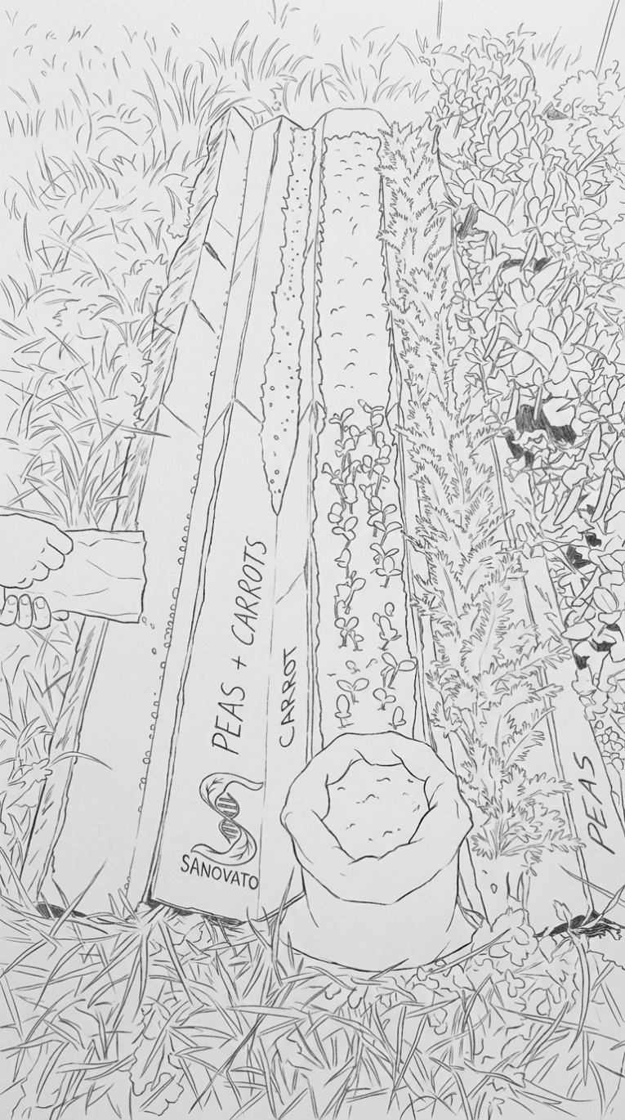
1. About the product
Dear customer, you have purchased an innovative Sano growing tool Seeding Comb (Seeding Comb) . The product is designed on the basis of modern principles of no-till agriculture ( no- till agriculture) and permaculture . Its primary function is the optimization of sowing in precise rows, targeted distribution of fertilizer, effective water management and mechanical suppression of the growth of unwanted weeds.
The product is made of profiled 5-layer corrugated cardboard 2240 x 2400 mm with a thickness of 7 mm, which ensures its prolonged mechanical resistance during the growing season. The material is fully hydrophilic (able to absorb water) and 100% biodegradable. The cardboard works as a temporary mulch (soil cover) and after its function ends, it becomes a source of carbon for the soil edaphon (soil organisms).
Material safety:
Environmental specification of packaging for safe soil application:
This packaging has been designed and tested to maximize compatibility with the soil ecosystem
Support and gluing ( Food-Grade Standard): Corrugated cardboard is connected exclusively with biodegradable native wheat starch, which meets the strictest standards for contact with food ( BfR , FDA). In the soil, it acts as a net source of carbon for the microbiome . Contains trace amounts of boron, which after release serves as an essential micronutrient for plant cell walls.
Active print (Mineral base): The print is realized with an inorganic water-based paint with a minimal content of volatile substances (VOC < 0.29%). Instead of synthetic carbon black, exclusively inorganic mineral Fe₃O ₄ (Pigment Black 11) is used . In the soil environment, this pigment weathers and, through microbial siderophores , provides bioavailable iron (Fe) for the root system.
Guaranteed purity: The complex material strictly guarantees the absence of heavy metals, endocrine disruptors ( bisphenols , phthalates ) and any substances from the list of SVHC ( Substances of Very High Concern ). There is no release of carcinogenic primary aromatic amines (PAA) or bioaccumulation of toxins in the soil.
Reference documents and component certification:
- Certificate for cardboard (starch binder): GDO Product Dossier ( Release 07, 2025-07-07) – approval for food contact, Vegan , Non -GMO.
- Certificates for adhesive additives: Declaration Minko SVHC (issued 30.06.2025) and Donauchem SVHC (issued 27.08.2025).
- Certificate for printing (healthy paint ): Declaration SVHC V.19.0 and declaration on the absence of heavy metals V.2.0 ( Siegwerk Druckfarben AG & Co. KGaA ).
- Color Material Specification: UNIBASE BLACK SD (Material Code: 12-904426-9.1470, Version 5.2).
So no heavy metals, no plastics, no synthetic binders and toxic dyes. It would be strictly against our company policy. The certificates are on our website www. sanovato.com/what-is-sadbovy-reben/
2. Functional mechanism of Sano Seeding Comb
The geometry of the product is based on alternating peaks and valleys (grooves), which creates a specific microclimate for plants:
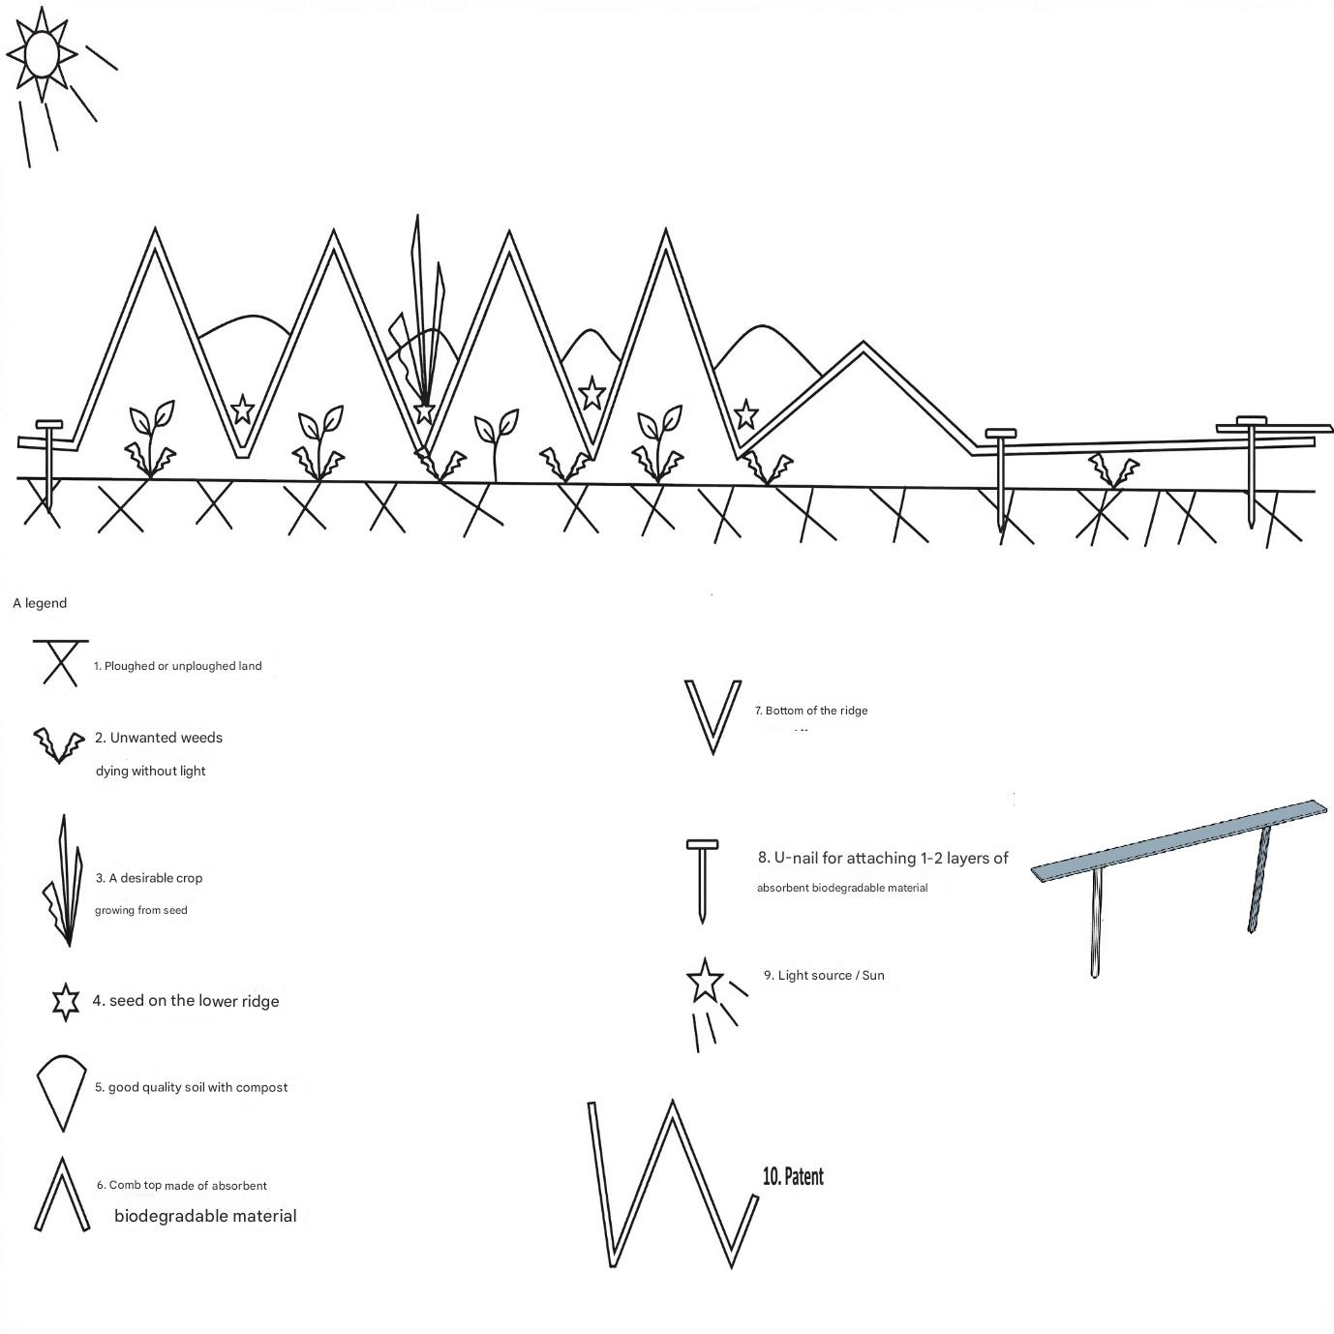
- Ridge tops: Provide a mechanical barrier and shade the inter-row space. Water runs down them into the grooves, thanks to which the tops dry out faster, which slows down their degradation. Unlike ordinary cardboard, the material in the bends is processed by a professional punch, which prevents premature breakage and loss of the shielding function.
- Ridge bottoms = Bottom grooves (seed beds ): They serve as collection lines for seed and granular fertilizer. During surface scattering, the seed falls precisely into these grooves under the influence of gravity. The subsequent backfilling of the grooves with matured compost or substrate creates an ideal environment for germination. Biological interaction: In a humid environment and in direct contact with the soil, the material at the bottom of the grooves will gradually soften. Cellulose serves as a substrate for saprophytic fungi and microorganisms. This process supports the formation of mycorrhizae (symbiotic coexistence of fungi and plant roots), which significantly increases the absorption surface of the root system and facilitates the deep rooting of the crop.

3. Main benefits for cultivation
- Weed elimination without herbicides : The surface area of the product prevents the access of light to the surface of the soil. Weed seeds in the soil bank either do not germinate, or the germinated plants die due to the absence of photosynthesis. At the time of complete degradation of the cardboard, the cultivated culture is already developed enough to naturally compete with the viable weeds. This eliminates the need for strenuous manual maintenance.
- Perfect spatial organization: The product creates exact parallel lines with defined spacing. This system is fully compatible with standard mechanization for manual platting (working range 140-320 mm).
- Efficient water management: The ridge geometry directs rainwater and artificial irrigation directly to the seed and root zone. Covered soil minimizes evaporation and protects soil organisms (e.g. earthworms) from predators and drying out.
- Protection of the soil microbiome : Installation does not require deep plowing or shoveling. This preserves the natural structure of the soil and symbiotic ties, which increases natural fertility in the long term.
- Integrated marking system: Wide surface lamellas allow direct description (variety name, sowing date) using a standard marker .

4. Instructions for application and installation
Step 1: Preparation of the substrate
The planting comb can be applied to ploughed, loosened, but also to untreated soil or low-cut lawn. Just lightly level the surface mechanically before application .
Sano rows and walkways
Seeding Comb is spatially variable. Adapt the configuration to the required width of the bed:
  - For maximum comfort with wide sidewalks : By leaving the edge lamellas (lamellas 1–2 and 13–14) in a unfolded state on the ground, you create stable walking surfaces. They prevent the formation of mud, prevent soil compaction in the root zone and facilitate harvesting. (However, they can also be used for covering when using "Záhonov rozum" with composting organic waste - the 2 middle slats of the product will become a new sidewalk)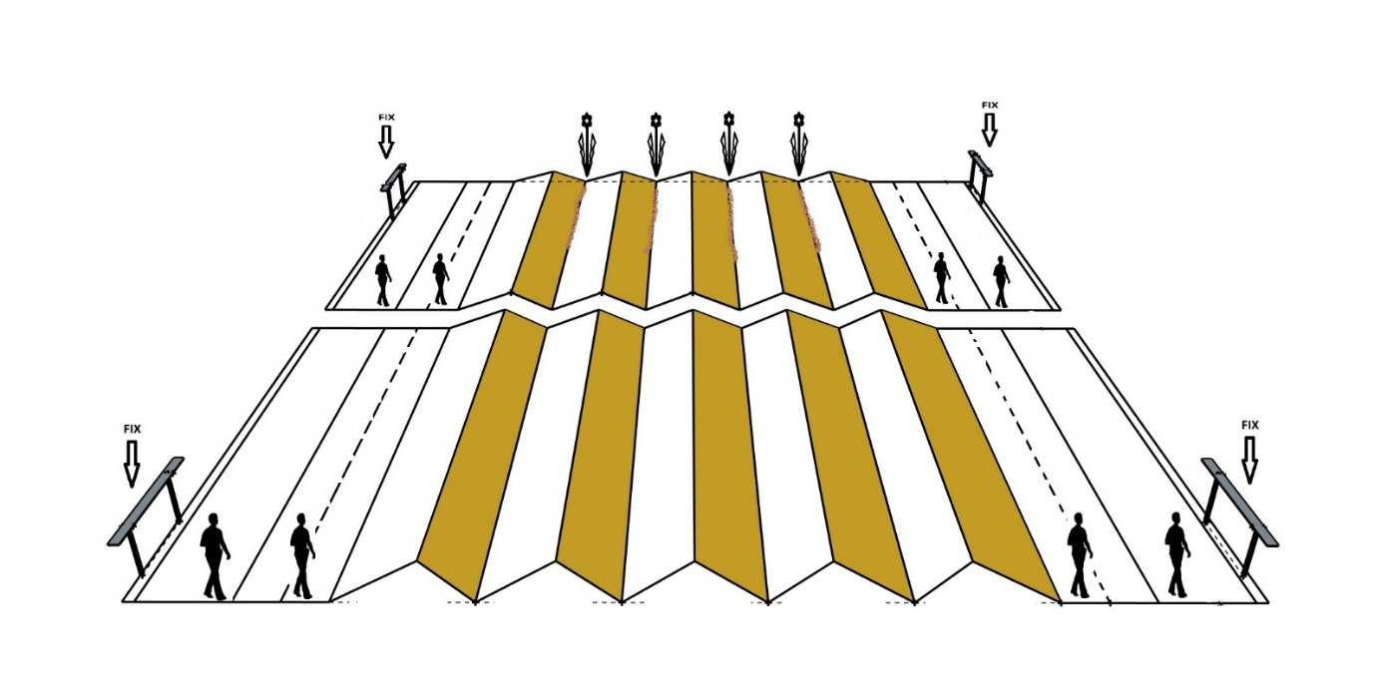
- Narrowed bed with maximum yield : On the penultimate beds there is a so-called bigovanie (extruded guide grooves). By applying slight pressure along these grooves, you can bend the slats to create an additional ridge (canopy). This action narrows the pavement and gives you another seeding groove.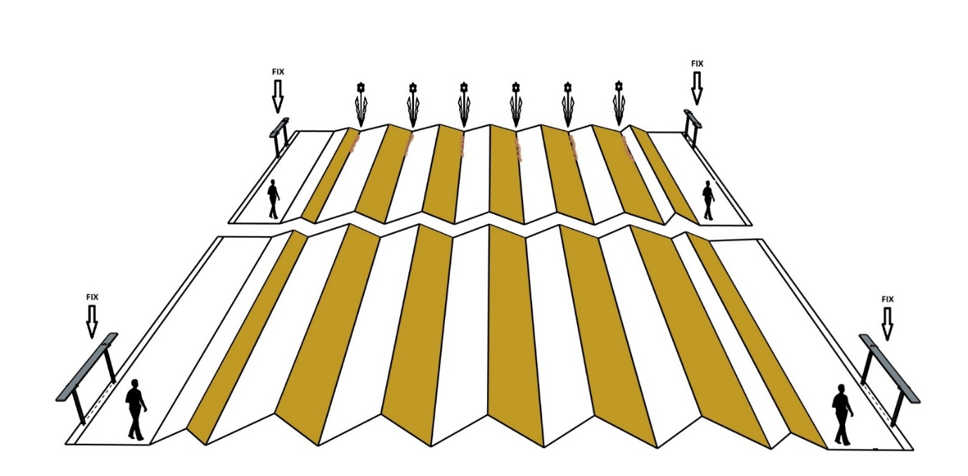
or you can cancel sidewalks entirely:
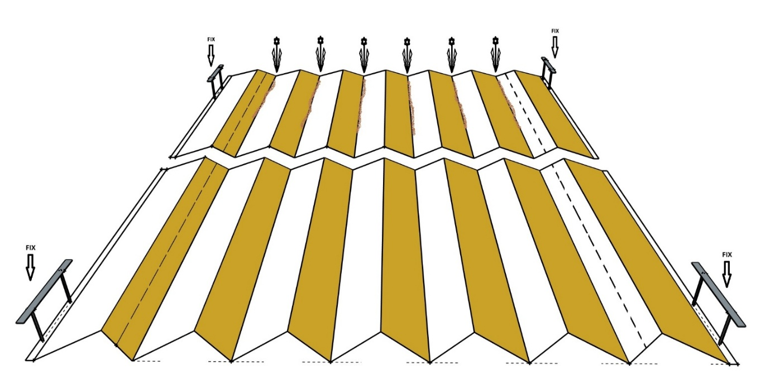
(Note: In windy weather, we recommend temporarily loading the ridge during forming with, for example, metal rods/ rockers , until the grooves are filled with earth).
Step 3: Anchoring to the ground
A properly formed ridge must be mechanically fixed to the ground to withstand the effects of the wind until it settles naturally.
We recommend using stainless steel U-clips (U-nails) for anchoring the edges. Their advantage is high strength, resistance to corrosion and simple removal after the season.
(Warning: We do not recommend using cheap plastic anchors. Due to UV radiation and frost, they become brittle, break in the soil and contaminate it with microplastics . Standard iron nails with a small head corrode quickly in the soil and are difficult to find).
Step 4: Sowing and Compost Application
- Spread the seed and granular fertilizer over the area. The material will naturally slide to the bottom of the grooves.
- Cover the seeding grooves evenly with a layer of high-quality compost or growing substrate ( Critical note: Use only thermophilically processed (well-ripened) compost, where the processing temperature has exceeded 55 °C. This is the only way to guarantee that you do not carry viable seeds of new weeds into the grooves.
- If rain is not expected, water the entire installed area evenly to start the process of germination and softening of the lower part of the cardboard.

Production and distribution:
SANOVATO Ltd.​
Jelsova 3, 92701 Sala]
Slovak Republic
www.sanovato.com
sanovatosk@gmail.com

